Pendulum Hardware Constants
Touchton, Noah
Section 12105 Date 11/6/25

TABLE I
Measured and Calculated Constants
Variable |  | Value | Method
R | 16 ohms |  | Data Sheet
K_{m} | 0.525 Nm/A |  | Calculation with Data Sheet Values
L₁ | 0.1231 m |  | Ruler
M₂ | 0.00377 kg |  | Scale
J₂ | 0.0001374 kgm² |  | Calculated
l₂ | 0.1472 m |  | Ruler
b₁ | 0.0146 Nms/rad |  | Solving for transfer function constants then relating them to dynamics
J₀ | 0.0024 kgm² |  | Solving for transfer function constants then relating them to dynamics
b₂ | 4.72*10⁵ Nms |  | Measured the damping of the pendulum experimentally

State Space Matrices
The A matrix is shown by (1).

$$A=\left[\begin{matrix}0 & 0 & 1 & 0 \\ 0 & 0 & 0 & 1 \\ 0 & -2.075 & -14.57 & -0.0139 \\ 0 & -52.57 & -9.38 & -0.3525\end{matrix}\right]$$ | (1)
The B matrix is shown by (2).

$$B=\left[\begin{matrix}0 \\ 0 \\ 15.03 \\ 9.67\end{matrix}\right]$$ | (2)

The C matrix is shown by (3).

$$C=\left[\begin{matrix}1 & 0 & 0 & 0 \\ 0 & 0 & 1 & 0\end{matrix}\right]$$ | (3)

The D matrix is shown by (4).

$$D=\left[0\right]$$ | (3)

The impulse response of the pendulum absolute angle is shown in Fig 1 and the impulse response of the platen angle is shown in Fig 2.

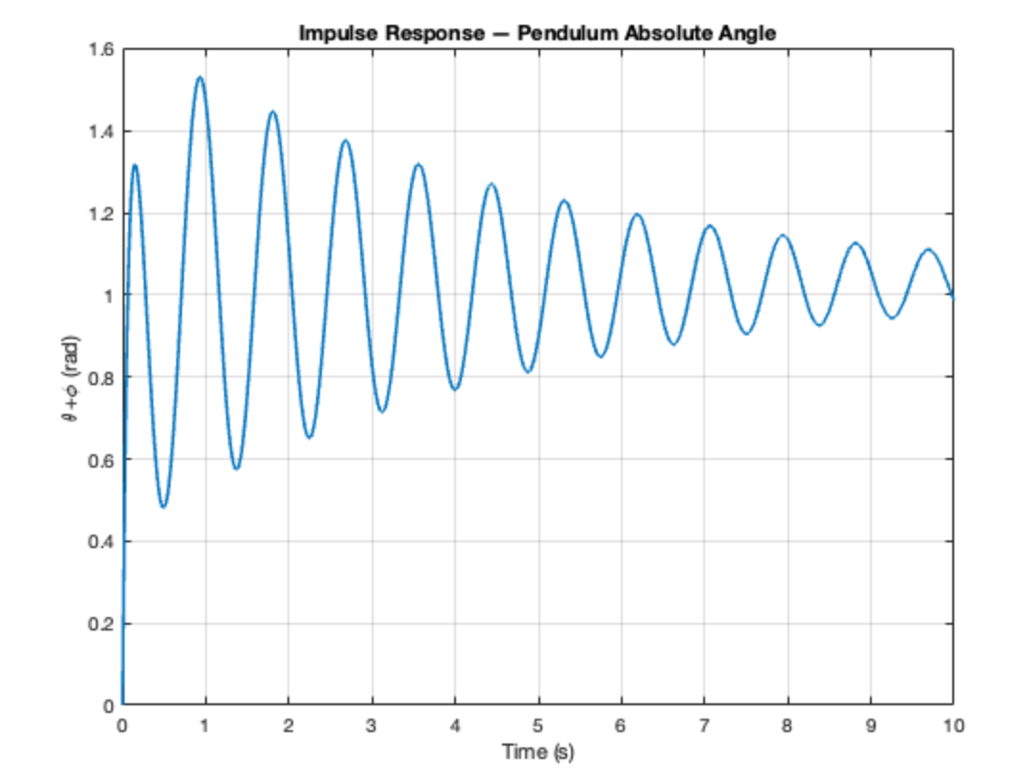
Fig 1.
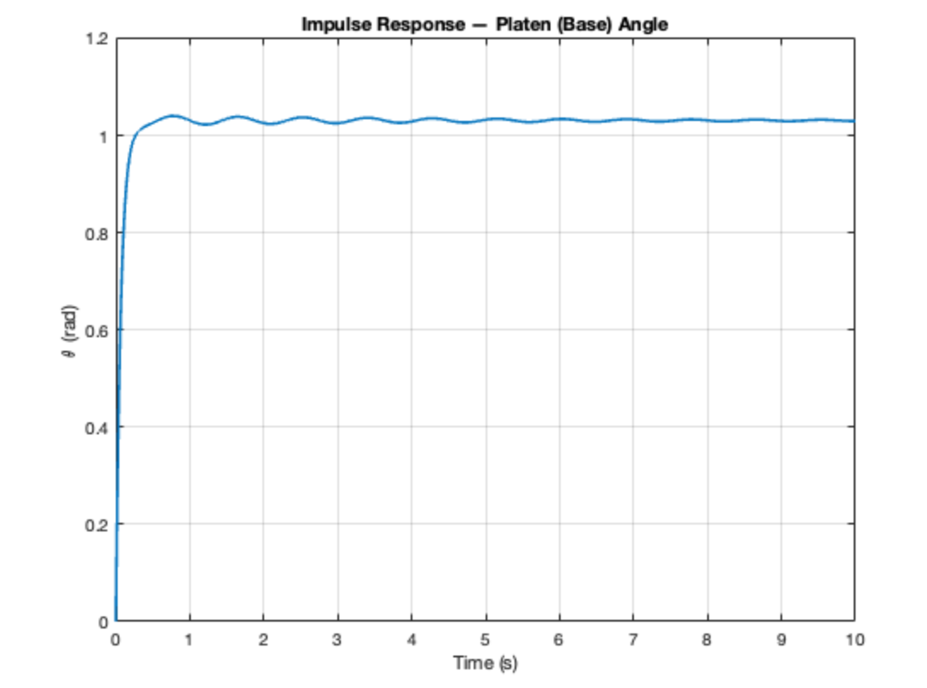
Fig 2.

